7th October 2025

BIGGER CANS, BIGGER CHEERS: JAMESON, GINGER & LIME READY-TO-DRINK CANS ARE BACK!
Jameson is making sure fans across the country are matchday ready for any on-the-go adventure with a new 330ml ready-to-drink (RTD) format
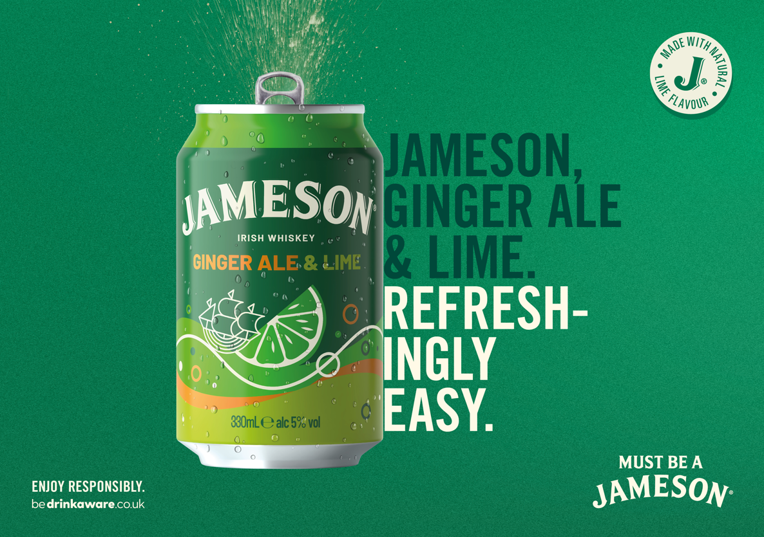
Jameson is bringing back fan favourite – Jameson, Ginger & Lime Cans – in a larger 330ml format. Previously available as a 250ml, the bigger can is being launched during a championship-worthy season for the brand, which is comfortably sitting in a Top 10 position in the UK Spirits league.

RTDs are holding position as the number one value-gaining category across the UK Off-Trade, growing +13%, with pre-mixed whiskey drinks increasing sales value by £3.5m. Jameson is growing across both the On- and Off-Trade, building brand equity within a key consumption pool for RTDs, 19–24-year-olds, thanks to its long-term partnerships including the English Football League (EFL). The partnership will support the launch through sampling activity from the Jameson bus, Orla Board, close to highly anticipated EFL matches such as finals.

Ian Peart, Commercial Director for Pernod Ricard UK, comments: “The RTD market is rapidly expanding in the UK and Jameson continues to inspire consumers by engaging them through their passion points, the number one being football. This means, showing up for fans in a way that makes their matchday experience smoother, with great drinks, prizes, collaborations and content that resonates. The new, larger 330ml format will make it even easier to enjoy a smooth Jameson Irish Whiskey both at home or away.”

Jameson Ginger & Lime RTDs will be available from 6th October in Tesco, Co-Op, Morrisons, Waitrose, as well as wholesalers including Bestway and Dhamecha. RRP £2.39. As the EFL’s official whiskey sponsor, the cans will also be available in select EFL stadiums across the country.

- ENDS –

About Pernod Ricard UK
Pernod Ricard UK is part of Pernod Ricard, a worldwide leader in the spirits and champagne industry, blending blending traditional craftsmanship, state-of-the-art brand development, and global distribution technologies. Our mission is to ensure the long-term growth of our brands with full respect for people and the environment, while empowering our employees around the world to be ambassadors of our purposeful, inclusive and responsible culture of authentic conviviality. Pernod Ricard’s consolidated sales amounted to € 10,959 million in fiscal year FY25. Pernod Ricard is listed on Euronext (Ticker: RI; ISIN Code: FR0000120693) and is part of the CAC 40 and Eurostoxx 50 indices.
Pernod Ricard holds one of the most prestigious brand portfolios in the sector, including 17 of the Top 100 Spirits Brands. Pernod Ricard UK has identified the following key priority brands in the UK market: Absolut, Jameson, Malibu, Kahlúa, Lillet, Italicus, Altos, Havana Club, Bumbu, Malfy, Monkey 47, Chivas, The Glenlivet, Perrier-Jouët, Campo Viejo, and Brancott Estate. Pernod Ricard UK is a member of The Portman Group promoting responsible drinking.

IWSR Gross Fixed Value Sales Data
Nielsen IQ 6/09/25 L52wks
52 w/e Nielsen data to 17.6.25
IPSOS 2024 report

