PERNOD RICARD UK HEADS DOWN THE RABBIT HOLE WITH NEW
SUPER PREMIUM KENTUCKY WHISKIES
Fastest growing Bourbon in the US now available in the UK

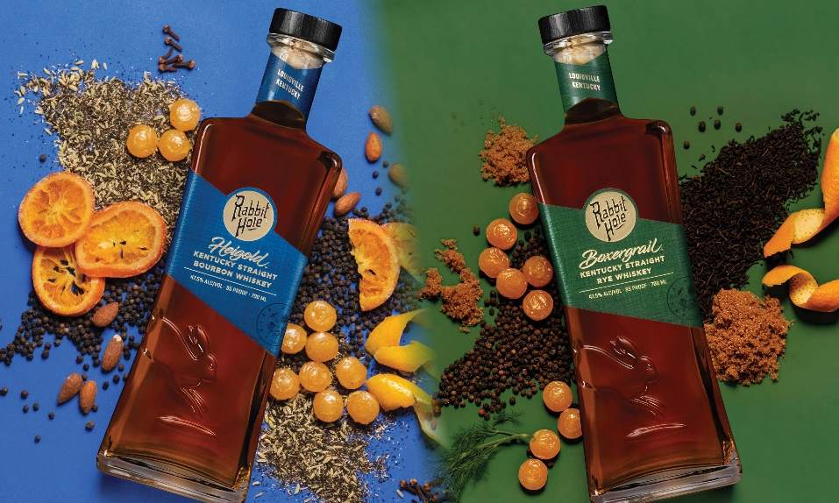

Pernod Ricard UK has welcomed Rabbit Hole to its portfolio of Enterprise Brands. Founded in 2012, Rabbit Hole is one of the fastest growing super premium American Whiskey brands in the US, and the UK will be the first market in Europe to launch the brand. The Rabbit Hole collection in the UK will include Heigold Kentucky Straight Bourbon Whiskey and Boxergrail Kentucky Straight Rye Whiskey.

Rabbit Hole was founded by Kaveh Zamanian who marries heritage techniques with innovative mash bills to create unique expressions of super premium American whiskey. Each bourbon in the Rabbit Hole portfolio has its own identity, unified by Kaveh’s uncompromising approach to whiskey making. Made in small batches with less than 15 barrels per batch, each bourbon comprises of 30% malted grains which deliver unique flavours and added complexity. Through its proprietary process, the liquid enters the barrel at a low entry proof and is never chill filtered to preserve its integrity. All the barrels used by Rabbit Hole are hand-selected, and unlike most barrels, are toasted and charred to bring out caramelised flavour.

Heigold, a high rye, double malt bourbon is made with a high concentration of malted grains, (5% malted barley and 25% malted rye) which places a distinct twist on a timeless recipe. With a sweet nose that evokes toasted malt, Heigold brings forth creamy notes of butterscotch with bursts of citrus, and finishes with intriguing notes of pepper and spice. Boxergrail is a Kentucky straight rye whiskey. This sour mash rye is composed of 95% Rye with malted barley added to its mash bill to present a velvety mouthfeel, while subtle spice and brown sugar notes lend an air of distinction. Bold and unexpected, this whiskey echoes an uncompromising spirit and sense of refinement.

All the whiskies in Rabbit Hole’s portfolio have been given names that reflect the Louisville, Kentucky individuals who have gone down their own ‘rabbit holes’ in pursuit of their passions. Heigold was named after Christian Heigold, a German stonemason who settled in Louisville prior to 1850 and carved ornate symbols of his patriotism on the façade of his landmark home. Boxergrail was inspired by Louisville’s rich heritage in boxing, where many local fighters emerging from neighbourhood gyms have followed a path to become prize-fighting champions.

Kaveh Zamanian, Rabbit Hole founder/whiskey maker, said: “Our expansion to the UK marks a pivotal moment for Rabbit Hole because I have long believed that American whiskey deserves to be on the global stage among the finest spirits in the world. Our heritage-based and innovation-forward approach to whiskey making has earned us a devoted following in the U.S. and we look forward to sharing our craft with spirits connoisseurs throughout the U.K.”

Mark Makin, Enterprise Brands Controller at Pernod Ricard UK, said: “As we continue to identify and incubate the next generation of cult spirit brands, we’re excited to welcome Rabbit Hole to our portfolio. Rabbit Hole is a modern and progressive distillery that makes award-winning whiskies and, as the fastest growing Bourbon in the US, has redefined the standard for American Whiskey. We’re confident that UK consumers will also embrace the brand and its one-of-a-kind expressions, and we look forward to sharing it with bourbon lovers and spirits enthusiasts across the country.”

Both Rabbit Hole expressions are 47.5% ABV and available in 750ml bottles. Heigold (RRP £55) and Boxergrail (RRP £49) is available from Master of Malt, Amazon and The Whisky Exchange. On-Trade stockists include Speciality Drinks, Amathus, Venus, Coe Vintners and Enotria.

- END -

For further information please contact: Mo Brownridge mo.brownridge@pernod-ricard.com.

About Pernod Ricard UK
Pernod Ricard UK is part of Pernod Ricard, number two in wines and spirits with sales of €8,824m in 2020/2021. Created in 1975 by the merger of Ricard and Pernod, the Group has undergone sustained development, based on both organic growth and acquisitions: Seagram (2001), Allied Domecq (2005) and Vin&Sprit (2008).

Pernod Ricard holds one of the most prestigious brand portfolios in the sector, including 19 brands among the top 100 worldwide. Pernod Ricard UK has identified the following key priority brands in the UK market: Absolut, Jameson, Chivas, The Glenlivet, Plymouth Gin, Monkey 47, MALFY, KI NO BI, Italicus, Lillet, Malibu, Perrier-Jouët, Kahlúa, Beefeater, Campo Viejo, Brancott Estate, Olmeca, Havana Club, Martell, Jacob’s Creek, Lamb’s, Aberlour, G.H. Mumm and Wyborowa. Pernod Ricard UK is a member of The Portman Group promoting responsible drinking.

For latest news and information: Website www.pernod-ricard.com/en/locations/uk Twitter @pernodricarduk

About Rabbit Hole
Diversifying the spirits landscape with one-of-a-kind whiskeys is Kentucky-based Rabbit Hole. Established in 2012 by Founder and Whiskey Maker Kaveh Zamanian, Rabbit Hole unifies heritage techniques with innovative, exclusive mash bills and out-of-the-box thinking to create singular expressions of super premium American whiskey. Through its signature bottlings – Cavehill Kentucky Straight Bourbon Whiskey, Boxergrail Kentucky Straight Rye Whiskey, Dareringer Straight Bourbon Whiskey Finished in PX Sherry Casks and Heigold Kentucky Straight Bourbon Whiskey, and its innovative Founder’s Collection series, Rabbit Hole turns the whiskey world on its tail, inviting imbibers to take a sip and dive down the rabbit hole, where “there’s no going back™.” The brand’s iconic, awe-inspiring distillery, named the architectural icon of the Kentucky Bourbon Trail, produces 1.7 million proof gallons annually and showcases the entire process of crafting bourbon from grain to bottle, unlike any other distillery in the country. Rabbit Hole was recently ranked the “fastest growing bourbon” by AC Nielsen (2021). Follow Rabbit Hole on Instagram @Rabbit Hole and Facebook @ Rabbit Hole Distillery.

52 Week Nielsen Total US x AOC + Liq Plus Volume Change ending 11/13/21
Whisky Advocate magazine (US) awarded Boxergrail 93 points in 2020, and Heigold 92 points in 2019

