ABSOLUT LAUNCHES NEW LIMITED EDITION BOTTLE INSPIRING WAVEMAKERS TO MAKE THEIR VOICES HEARD

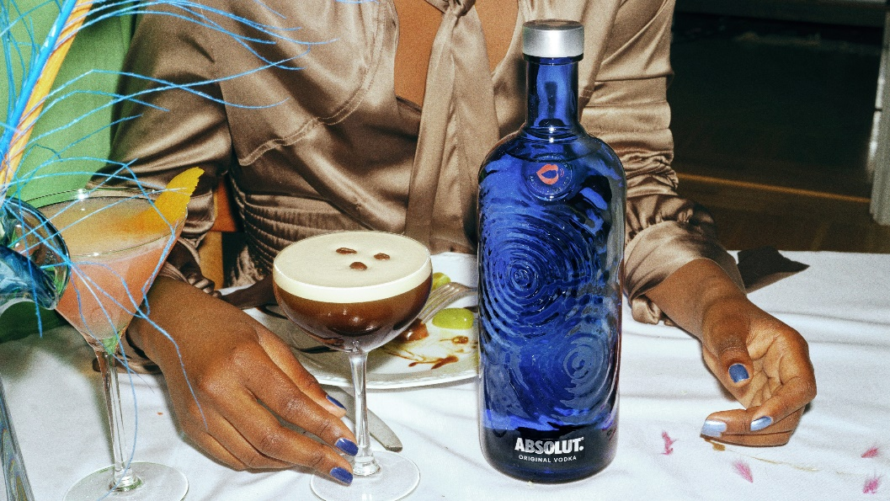

Absolut, the UK’s No. 1 premium vodka, is launching a new limited-edition bottle uniquely designed with expanding sound ripples to resemble and hero the power of voices from all over the world, to champion speaking up and to create a more open world. Available from February, the sapphire blue Absolut Voices bottle is made using 80% recycled glass, and also features a custom medallion in one of four vibrant colours.

The new release is part of an annual programme of limited-edition bottles from Absolut and is a celebration of the wavemakers and trailblazers of the world, and embodies the brand’s core belief that the world becomes a better place when we mix together beyond differences. Absolut Voices shakes things up by encouraging people to connect for more inspiring and memorable moments. It is a powerful reminder of how bringing people from all walks of life closer can bring new perspectives, ideas and ways of thinking to empower progress in society.

Marnie Corrigan, Brand Director at Pernod Ricard UK, commented: “Celebrating diverse and different viewpoints has always been in our spirit, and the soundwaves on our new limited edition bottle represent the powerful voices we continue to support around the globe, and also signifies the impact and progress a society can make when different minds come together. We’re constantly inspired by the idea that the world becomes a better place when we come together, share perspectives and empower one another, because we are born to mix. No matter where, or with whom, you’re mixing in the world, you can connect with Absolut.”

Absolut is growing in value more than triple the rate of the Total Vodka category, and the brand will be supporting the launch of Absolut Voices with a 360-campaign including in-store media, social and influencer activity to drive awareness. The new limited-edition bottle will be available in a 70cl format from all major grocers and wholesalers (RRP £19.95) and 1L from Costco and Amazon (RRP £25.50).

- END -

For further information please contact: Mo Brownridge mo.brownridge@pernod-ricard.com.

About Pernod Ricard UK
Pernod Ricard UK is part of Pernod Ricard, number two in wines and spirits with sales of €8,824m in 2020/2021. Created in 1975 by the merger of Ricard and Pernod, the Group has undergone sustained development, based on both organic growth and acquisitions: Seagram (2001), Allied Domecq (2005) and Vin&Sprit (2008).

Pernod Ricard holds one of the most prestigious brand portfolios in the sector, including 19 brands among the top 100 worldwide. Pernod Ricard UK has identified the following key priority brands in the UK market: Absolut, Jameson, Chivas, The Glenlivet, Plymouth Gin, Monkey 47, MALFY, KI NO BI, Italicus, Lillet, Malibu, Perrier-Jouët, Kahlúa, Beefeater, Campo Viejo, Brancott Estate, Olmeca, Havana Club, Martell, Jacob’s Creek, Lamb’s, Aberlour, G.H. Mumm and Wyborowa. Pernod Ricard UK is a member of The Portman Group promoting responsible drinking.

For latest news and information: Website www.pernod-ricard.com/en/locations/uk Twitter @pernodricarduk

AC Nielsen, Total Off-Trade, Value Share MAT to 01.01.22
AC Nielsen, Total Off-Trade, Value Sales MAT to 01.01.22

