SIP ON A SLICE OF SUMMER WITH MALIBU’S NEWEST FLAVOUR & RTD: MALIBU WATERMELON AND MALIBU WATERMELON LEMONADE

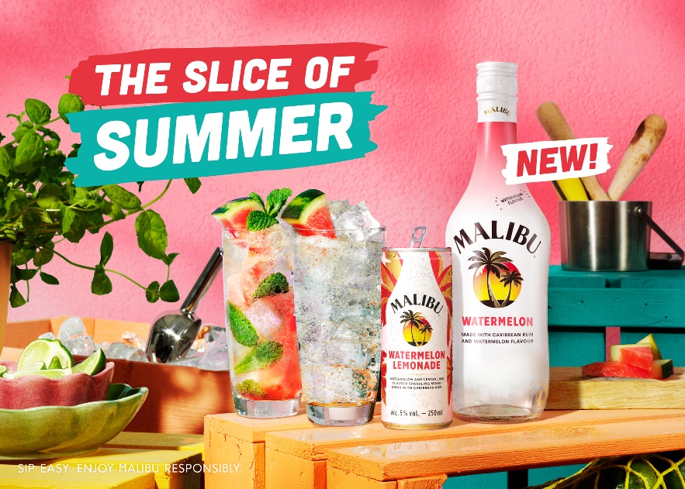

Malibu is launching two new products offering a slice of summer to the brand’s 18-24 year-old consumer. Malibu Watermelon and Malibu Watermelon Lemonade taps into the increased demand for watermelon flavour alcoholic drinks, which has grown +63% YoY. The brand is looking to continue this momentum by celebrating the most refreshing flavour of the season and adding to its flavour portfolio.

Malibu Watermelon
Malibu’s latest tropical thirst quencher is full of flavour. Bringing together Caribbean rum, blended with the ripe, juicy and refreshing taste of Watermelon and a smooth and fruity finish, Malibu Watermelon is made for summer.

Simply add lemonade for chilled moments with friends, or stir things up with a Malibu Watermelon Mojito. Available in a 70cl bottle with a 21% ABV, Malibu Watermelon has an RRP of £15.

Malibu Watermelon Lemonade
Refreshing taste has never been easier, as summer lovers can also enjoy Malibu Watermelon’s hero serve in a ready-to-drink format. The newest addition to the Malibu can family, Malibu Watermelon Lemonade is a sparkling blend of Caribbean rum and watermelon, with lemon lime flavours for a burst of sweetness.

Tapping into at-home consumption and alfresco moments, Malibu Watermelon Lemonade is perfectly positioned to fill this market need. The pre-mixed drinks category is growing +26.8% YOY and the Malibu can range is growing +50.2%, over double the rate of the pre-mixed drinks can category (19.2%). Malibu Watermelon Lemonade 250ml cans have an ABV of 5% and an RRP of £1.80.

Chris Shead, Channel Director at Pernod Ricard UK, said: “Malibu is a true icon of summer and with flavoured spirits on the rise, the brand’s latest innovations are sure to be a sizzling hit. We’re delighted to be extending our current can offering at a time when the ready-to-drink market is booming, and Malibu’s RTD range has gone from strength to strength over the last three years, helping to recruit younger shoppers into the brand. These two new additions to the Malibu family are primed to take this summer over by clearly answering consumer needs for great tasting drinks, suitable for all daytime occasions.”

Malibu Watermelon Lemonade 250ml can is available now in Tesco and Morrison’s, and Malibu Watermelon 70cl is available in Tesco and Asda. Both SKUs are also available from wholesalers including Bestway, Booker and United.

- ENDS -

For further information please contact: Mo Brownridge mo.brownridge@pernod-ricard.com.

Notes to Editors

Malibu Watermelon & Lemonade

Ingredients:
- 50ml Malibu Watermelon
- Top with Lemonade
- Garnish with fresh watermelon

Method:
Fill highball glass with ice. Add Malibu and lemonade. Garnish with a watermelon slice.

Malibu Watermelon Mojito

Ingredients:
- 50ml Malibu Watermelon
- 15ml Lime juice
- 100ml Soda water, or lemonade for a sweeter taste
- Mint leaves
- Fresh watermelon

Method:
Add watermelon pieces, mint leaves and lime juice into a highball glass. Gently muddle and then fill glass with ice. Add Malibu Watermelon and top with soda water/lemonade. Garnish with mint sprig and watermelon wedge

About Pernod Ricard UK
Pernod Ricard UK is part of Pernod Ricard, number two in wines and spirits with sales of €8,448m in 2019/2020. Created in 1975 by the merger of Ricard and Pernod, the Group has undergone sustained development, based on both organic growth and acquisitions: Seagram (2001), Allied Domecq (2005) and Vin&Sprit (2008).

Pernod Ricard holds one of the most prestigious brand portfolios in the sector, including 19 brands among the top 100 worldwide. Pernod Ricard UK has identified the following key priority brands in the UK market: Absolut, Jameson, Chivas, The Glenlivet, Plymouth Gin, Monkey 47, MALFY, KI NO BI, Italicys, Lillet, Malibu, Perrier-Jouët, Kahlúa, Beefeater, Campo Viejo, Brancott Estate, Olmeca, Havana Club, Martell, Jacob’s Creek, Lamb’s, Ballantine’s, G.H. Mumm and Wyborowa. Pernod Ricard UK is a member of The Portman Group promoting responsible drinking.

For latest news and information: Website www.pernod-ricard-uk.com Twitter @pernodricarduk

GNPD Mintel Q1 2019
AC Nielsen | Pre-mix | Total Off-Trade | Value Sales MAT to 27.03.21

