MALIBU TO LET THE FUNSHINE THIS SUMMER
- Immersive experience comes to London and Manchester, with backdrops inspired by summer moments and Malibu cocktails
- Pop-up to drive footfall into the On-Trade with Piña Colada promotion in partnership with Revolutions Bars
- ‘Pick up a Piña Colada’ game launched to celebrate Piña Colada Day
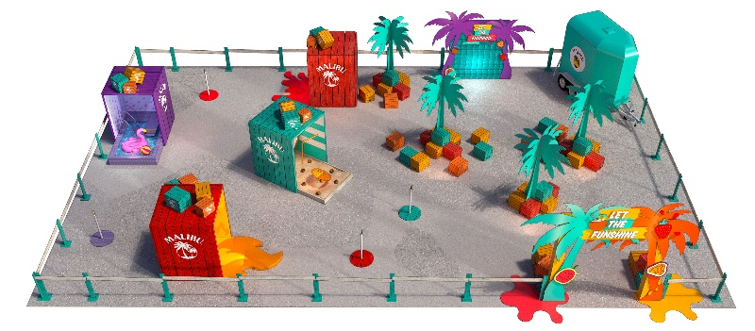
The UK’s no.1 coconut rum brand is inviting consumers to #LetTheFunshine with the launch of a Malibu-inspired immersive experience and augmented reality game. The activity is set to capitalise on the popularity of the brand, as Malibu is experiencing +49.7% value growth, well ahead of the Liquers & Specialities category (+38.2%).

The pop-up event will be coming to London’s Truman Brewery in Shoreditch between 30th June - 4th July and Manchester’s Spinningfields Square between 7th - 11th July, and will feature summer-themed photo booths, each inspired by different Malibu cocktails, DJs spinning the latest hits, and a chill out bar area. The Malibu #LetTheFunshine experience will be free to attend with advance sign-up through Fever or tickets are available on the door.

Upon arrival, guests will be presented with a free Malibu ready-to-drink can before heading towards the immersive photo huts. Each one will allow consumers to relive their favourite holiday memories, including being whisked away to the waterside with the help of some fun props, and getting behind the coals of a typical summer barbecue. Fans of the brand will also be able to explore Malibu coconut and watermelon moments brought to life in 4D. A choice of seven Malibu serves will also be available from the Tiki Trailer Bar including Malibu Piña Colada, Malibu Watermelon Mojito and a Malibu Strawberry Spritz, to provide a refreshing taste of summer.

All visitors will have the chance to win a tab for them and three friends at the Revolutions Summer Brunch event in August by sharing their experience on Instagram or Twitter by posting using #LetTheFunshine and tagging @MalibuRumUK and @RevolutionsBars. Guests will also be given a redeemable voucher for a free Piña Colada at any UK Revolutions Bar valid between 8-10th July in celebration of National Piña Colada Day.

Marnie Corrigan, Brand Director at Pernod Ricard UK comments, “Malibu is committed to liberating the fun spirit of summer and our #LetTheFunshine experience is our way of bringing moments of joy to consumers. Nothing beats the feeling of sipping a cold cocktail on the beach, and with travel restrictions still in place, our immersive experience will transport Generation Z to their personal paradise as Malibu once again delivers the true taste of summer.”

In celebration of Piña Colada Day on 10th July, Malibu has also created a ‘Pick up a Piña Colada’ augmented reality game offering consumers the chance to win one of 50,000 Piña Coladas being given away at participating bars between 6th - 11th July.

-ENDS-

For further information please contact: Mo Brownridge mo.brownridge@pernod-ricard.com.

Notes to Editors

About Pernod Ricard UK
Pernod Ricard UK is part of Pernod Ricard, number two in wines and spirits with sales of €8,448m in 2019/2020. Created in 1975 by the merger of Ricard and Pernod, the Group has undergone sustained development, based on both organic growth and acquisitions: Seagram (2001), Allied Domecq (2005) and Vin&Sprit (2008).

Pernod Ricard holds one of the most prestigious brand portfolios in the sector, including 19 brands among the top 100 worldwide. Pernod Ricard UK has identified the following key priority brands in the UK market: Absolut, Jameson, Chivas, The Glenlivet, Plymouth Gin, Monkey 47, KI NO BI, Italicus, Lillet, Malibu, Perrier-Jouët, Kahlúa, Beefeater, Campo Viejo, Brancott Estate, Olmeca, Havana Club, Martell, Jacob’s Creek, Lamb’s, Ballantine’s, G.H. Mumm and Wyborowa. Pernod Ricard UK is a member of The Portman Group promoting responsible drinking.

For latest news and information: Website www.pernod-ricard-uk.com Twitter @pernodricarduk

AC Nielsen | Specialities | MAT value to 27.03.21
AC Nielsen | Total Off-Trade | MAT value to 27.03.21
AC Nielsen | Specialities | MAT value to 27.03.21
Strict social distancing and health and safety processes will be in place, in line with government guidelines

