JACOB’S CREEK INVESTS IN BRAND WITH DIGITAL SUMMER GIFTING CAMPAIGN AND INTERNATIONAL CRICKET COUNCIL PARTNERSHIP
- Digital campaign to support new listings of the award-winning Double Barrel range
- Jacob’s Creek announced as Official Wine Partner for inaugural ICC World Test Championship Final

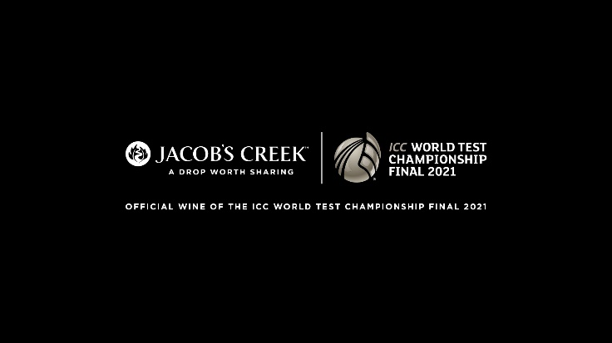

Jacob’s Creek, the UK’s best-known wine, has kicked off a strong investment plan to support the brand’s value strategy and long-term development in the UK market. The investment comes as the Jacob’s Creek Double Barrel range is growing +72.3%, well ahead of the super-premium category which is growing +40.3%. Australian wine also remains the leading Country of Origin and holds a 20.5% market value share.

The Double Barrel activity will focus on a digital ad campaign for the award-winning range running until the end of July. Additionally, a gifting campaign will run across Father’s Day and into the summer months with a focus on Instagram, Tabmo and programmatic display. Supporting new listings of the range secured in Asda, Tesco, Morrison’s and Sainsbury’s, the campaign also includes two limited-edition gift boxes available exclusively in Sainsbury’s across both its Shiraz and Chardonnay varietals. The Double Barrel range is crafted from superior quality grapes first matured in traditional wine barrels, then finished in aged whisky barrels for a richer, deeper, and smoother taste making the product a unique gift.

The brand has also been announced as the official wine partner for the inaugural ICC World Test Championship Final 2021 taking place in Southampton, 18th - 22nd June. As the official wine partner for the hugely anticipated ICC World Test Championship Final between India and New Zealand, Jacob’s Creek will have exclusive pouring rights for the event, branding at in-stadia bars, stadium and digital broadcast advertising. The event will kick-start a long-term strategic partnership for Jacob’s Creek with the ICC for the next three years.

Lucy Bearman, Wine Portfolio Director for Pernod Ricard UK, comments: “We’re committed to investing in the brand to support Jacob’s Creek reclaim the number one spot in the premium Australian wine category. We have a long-standing connection to the world of sport and as a wine brand that is all about connecting people, Jacob’s Creek is proud to partner with the ICC to bring people together in a celebration of cricket. UK wine consumers have also embraced the unique proposition of our Double Barrel range and we’re confident that our new digital and gifting campaign will create further engagement with the brand, and attract incremental shoppers to the category who are looking for a quality assurance that only Australia’s best-selling and UK’s most well-known wine brand can provide.”

The Double Barrel range launched in 2014 with a Shiraz finished in aged Scotch whisky barrels, and was joined last year by a Chardonnay crafted in aged Scotch whisky barrels, the first of its kind in the world. A Cabernet Sauvignon finished in aged Irish Whiskey barrels is the latest addition to the range, which launched in April. The range has an RRP of £12 and the gift boxes are available at the same price-point.

-ENDS-

For further information please contact: Mo Brownridge mo.brownridge@pernod-ricard.com.

Notes to Editors

About Pernod Ricard UK
Pernod Ricard UK is part of Pernod Ricard, number two in wines and spirits with sales of €8,448m in 2019/2020. Created in 1975 by the merger of Ricard and Pernod, the Group has undergone sustained development, based on both organic growth and acquisitions: Seagram (2001), Allied Domecq (2005) and Vin&Sprit (2008).

Pernod Ricard holds one of the most prestigious brand portfolios in the sector, including 19 brands among the top 100 worldwide. Pernod Ricard UK has identified the following key priority brands in the UK market: Absolut, Jameson, Chivas, The Glenlivet, Plymouth Gin, Monkey 47, KI NO BI, Italicus, Lillet, Malibu, Perrier-Jouët, Kahlúa, Beefeater, Campo Viejo, Brancott Estate, Olmeca, Havana Club, Martell, Jacob’s Creek, Lamb’s, Ballantine’s, G.H. Mumm and Wyborowa. Pernod Ricard UK is a member of The Portman Group promoting responsible drinking.

For latest news and information: Website www.pernod-ricard-uk.com Twitter @pernodricarduk

About the ICC
The International Cricket Council (ICC) is the global governing body for cricket. Representing 104 members, the ICC governs and administrates the game and works with our members to grow the sport. The ICC is also responsible for the staging of all ICC Events.

The ICC presides over the ICC Code of Conduct, playing conditions, the Decision Review System and other ICC regulations. The ICC also appoints all match officials that officiate at all sanctioned international matches. Through the Anti-Corruption Unit it coordinates action against corruption and match fixing.

About the WTC Final Broadcast
ICC’s global coverage will provide cricket fans with wide-ranging access to the match on television, digital and radio. The TV broadcast plans are headlined by long-term partner Star Sports, broadcasting in five languages in India namely Hindi, English, Tamil, Telugu and Kannada. Indian fans will also be able to watch video clips on Facebook. Additionally, to maximise reach, the ICC has agreed deals with leading global broadcasters, including Sky Sports in New Zealand, Fox Sports in Australia, Supersport in Sub-Saharan Africa, and Sky Sports in the UK. Fans in the US have an array of options, via Hotstar, ESPN+ and Willow TV.

Wine Intelligence | Vinitrac UK, October 2020
AC Nielsen | Total Off-Trade | MAT value sales to 27.03.21
AC Nielsen | Total Off-Trade | MAT value sales to 27.03.21
AC Nielsen | Total Off-Trade | MAT value sales to 27.03.21

