Absolut to Host Free Virtual Event with Superstar Performers MNEK and Joel Corry as the Nation Prepares to Come #TogetherIRL
The UK’s no.1 premium vodka is digitally connecting people for a night of music, art and mixology hosted by Munya Chawawa on 15th July

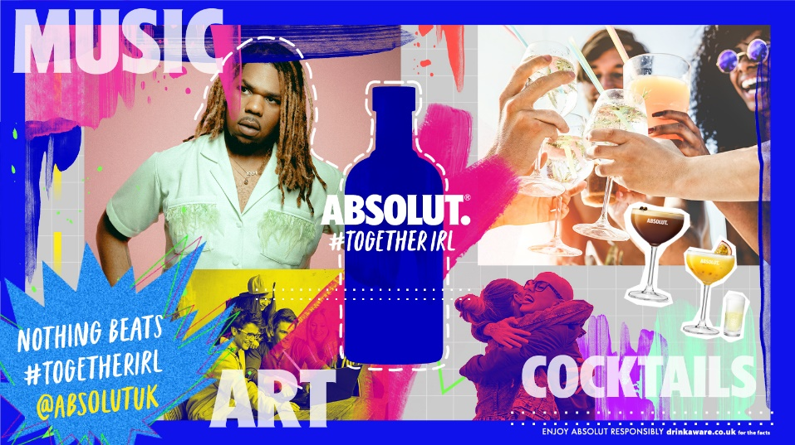

Absolut is getting ready to host an incredible virtual event that celebrates collective inspiration and human interaction as the UK prepares to connect once again after a year of being apart. Taking place on Thursday 15th July, ahead of when social distancing guidelines are due to be lifted in the UK, the #TogetherIRL event will be set against a backdrop of music, art and mixology, and viewers can tune in for free with their friends via Absolut’s Facebook page.

The digital celebration will see performances from Grammy-award-nominated musician MNEK, DJ’s Joel Corry and The Collyer Twins, and will be hosted by comedian, Munya Chawawa. An exclusive digital ‘sound portrait’ will be produced by contemporary artist, JP Jones, and a cocktail masterclass will teach those tuning in how to make an Absolut Passionfruit Martini and an Absolut Espresso Martini. At-home cocktail boxes are available to purchase in advance priced at £24.95 and contain all the ingredients to make two of each cocktail, glassware and a cocktail shaker.

The digital event forms part of Absolut’s global consumer engagement platform that celebrates the importance of meaningful connections, inspiring consumers to look forward to those moments where we’ll all be together again in real-life. This is the second time MNEK has worked with the brand, having featured in the ‘Nothing Beats #TogetherIRL’ national campaign earlier this year.

Marnie Corrigan, Brand Director at Pernod Ricard UK, comments: “We know that when different people collaborate, we can create incredible experiences and as the nation gets ready to come together again, we’re hosting one final digital celebration to help consumers do just that. Because Absolut believes in the power of community, we’re inviting everyone to join in the fun and connect with others wherever they are. The Absolut #TogetherIRL event is set to be a night to remember and a great way to celebrate the start of summer, because nothing beats being together in real-life.”

Absolut is growing +43.5% in value, more than twice the rate of total category growth. To coincide with the event, the brand is running a second burst of above-the-line media that will reinforce ‘nothing beats #TogetherIRL’ on video-on-demand, YouTube, social and out-of-home.

-ENDS-

For further information please contact Mo Brownridge mo.brownridge@pernod-ricard.com.

Notes to Editors

About Pernod Ricard UK
Pernod Ricard UK is part of Pernod Ricard, number two in wines and spirits with sales of €8,448m in 2019/2020. Created in 1975 by the merger of Ricard and Pernod, the Group has undergone sustained development, based on both organic growth and acquisitions: Seagram (2001), Allied Domecq (2005) and Vin&Sprit (2008).

Pernod Ricard holds one of the most prestigious brand portfolios in the sector, including 19 brands among the top 100 worldwide. Pernod Ricard UK has identified the following key priority brands in the UK market: Absolut, Jameson, Chivas, The Glenlivet, Plymouth Gin, Monkey 47, Lillet, Malibu, Malfy, KI NO BI, Italicus, Del Maguey, Perrier-Jouët, Kahlúa, Beefeater, Campo Viejo, Brancott Estate, Olmeca, Havana Club, Martell, Jacob’s Creek, Lamb’s, Ballantine’s, G.H. Mumm and Wyborowa. Pernod Ricard UK is a member of The Portman Group promoting responsible drinking.

For latest news and information: Website www.pernod-ricard-uk.com Twitter @pernodricarduk

AC Nielsen | Total Off-Trade Value | MAT to 27.03.21
AC Nielsen | Total Off-Trade Value | MAT to 27.03.21

